# Pets

You need to add 20 things to this document. (Make sure to number them just as I did in the example.) It may be helpful to copy and paste this list and then fill it in as you go along. All image names must start with your location, e.g yellowstone_sunset.jpg unless you are using a link from the internet.

## Garfield Cat

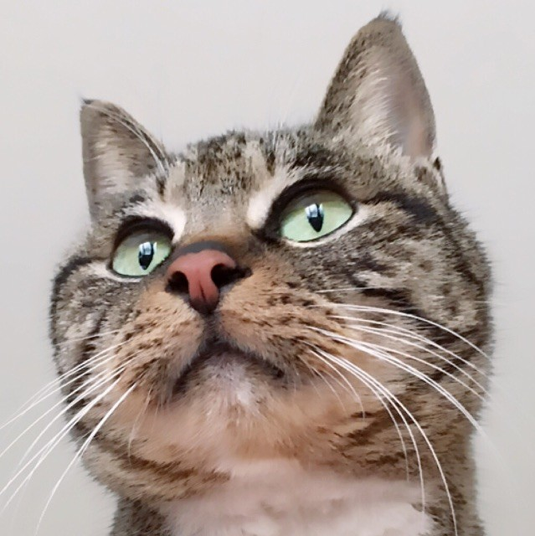

1. garfield.jpg
2. The elderly calico cat with brown hair and white beard
3. Garfield, the 18-year-old calico cat, embodies the wisdom of age with her distinguished appearance. Her fur, a patchwork of black, white, and orange, has mellowed over the years, showing the passage of time with grace.
4. Garfield's eyes, once lively, now emanate a serene and knowing gaze, a testament to the experiences she's gathered in her long life. Despite her senior status, Garfield exudes a timeless elegance, a living testament to the beauty of age.
5. **Photo Gallery**
6. garfield_lying.jpg
7. Garfield lying in the cage
8. garfield_food
9. Garfield eating cat food
10. garfield_spring
11. The cat in the Spring Festival
12. garfield_stand
13. Garfield trying to stand up
14. **Likes**
15. Scratching cardboard box
16. Shrimp
17. Licking electric wire
18. Rongzhen Jiang

## Bacon Q Dog



1. bacon.jpg
2. Brown labradoodle wearing colorful lei
3. Bacon Q. Dog is a 9yr old labradoodle. He prefers to spend his days lounging among the three different beds/couches that his family has gifted him. He enjoys a walk or two around the neighborhood, as long as he can pretend that he doesn't see any of the other animals to avoid the embarrassment of not wanting to admit he has no wolf-like skills in chasing them.
4. At night just as the rest of the family is ready to relax, Bacon suddenly wants to release all of his energy. He will place his toys on a mini couch and frantically drag the couch around, giving his toys "a ride." There is also a lot of rolling. Lots and lots of rolling.
5. **Photo Gallery**
6. bacon_bandana.JPG
7. Brown labradoodle wearing an orange bandana
8. bacon_graduation.JPG
9. Small labradoodle puppy wearing a graduation cap and gown.
10. bacon_agility.mov
11. Girl and dog demonstrating a sit and stay procedure
12. bacon_halloween.JPG
13. Brown labradoodle wearing a pirate costume
14. **Likes**
15. Belly rubs
16. Playing tug-of-war
17. Sneaking onto the couch
18. Colleen van Lent